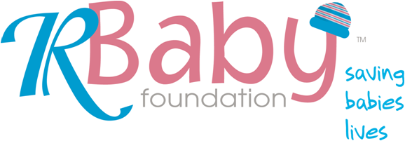

Reporting for Medical and Scientific Research Grants
Cover Sheet

Grant recipient to complete
Name of organization:

Project title:

Date of grant:
Duration of project & current stage:

Location(s) of project:

Funds granted & total project cost:

Statement of expenditure

Total amount of grant received:

Amount of grant expended to date:

Balance as at [date] :

Signed:

[Type in name & title/position]

Date:

Report Requirements

In your report, please address the questions below. Please limit the information you provide to 4 pages. You may include relevant attachments that go beyond the 4 pages, such as a report written in scientific language, if this helps to tell your story. Since we intend to share this information with as many expectant parents, current parents, and general consumers as possible, our goal is to keep the information in your report of 4 pages or fewer understandable and actionable. Please email your four page narrative and cover sheet to ar17@earthlink.net and Katie@rbabyfoundation.org AND print and send to

R Baby Grant Reports
c/o Powered by Professionals
1460 Broadway New York, NY 10036_

NARRATIVE REPORT

Project Summary

Please include a current, one-paragraph summary of the project.

Single Greatest Achievement during the Reporting Period

Please provide a one-sentence description of the single most important, measureable outcome during the period.

Project Scope

Summarize original project scope, then outline any significant changes made, the rationale for this and why not possible to communicate earlier, and any impact on the project outcomes.

Project Highlights

Please complete three sections below, with bullet points corresponding to questions.

Implementation

- Is the project moving forward in a timely fashion?
- Is the project developing as planned?

Impact
- What major results have been achieved?
- How many babies will be helped by this project?
- Will the standard of care be changed for infants?
- How many people are being trained/educated by the project?
- To what extent has their knowledge/comfort level of pediatric emergency medicine been enhanced?

Sustainability
- Is the infrastructure in place/being developed for the project to work effectively?
- What kind of organizational support is given to the grant activities?
- Plans to assure continued effectiveness of the program beyond R Baby’s commitment?

Additional Dissemination and Impact if not provided above

What action have you taken to promote awareness of any scientific results arising from your research?

How are you using the findings of your work to bring about improvements to the entire PED ER community?

What is your planned or executed dissemination effort?

Are you going to submit an abstract or publish an article in a peer reviewed medical journal?

Have you presented your work at a medical conference or symposium?

How many medical professionals have you trained?

How many cases have you reviewed or, more importantly, impacted?

How many babies lives have you saved? If you are unable to track this, what are your ideas regarding measuring the “end goal” of your program as aligned with R Baby Foundation’s only goal, which is to save babies lives?

Future Activity

What action will your organization take as a result of the project, or what is the action you consider needs to be taken by others?

How do you now intend to proceed with the development of your project over the next six months?

Reflections on working with R Baby Foundation’s team

We would appreciate any comments you can provide on your experience with R Baby Foundation representative and accessing the R Baby Foundation program!

